***The Geological Society of London:***

*East Anglian Regional Group*

*Evening Lecture*

***Risk and Uncertainty in Exploration for Oil and Gas***

*With*

***Malcolm Brown***

***President, Geological Society of London***

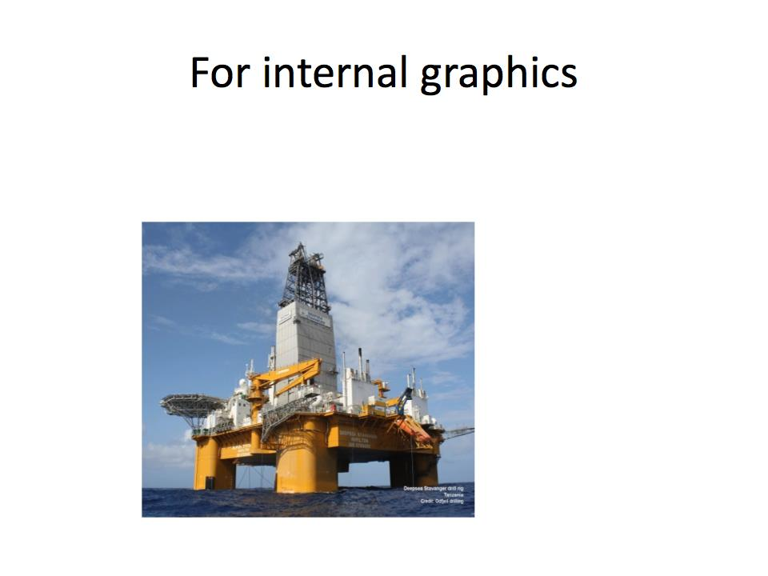

**Date: Tuesday 27th February 2018**

**Refreshments from 6.30 pm**

**Lecture starts at 7.00pm**

**Venue: Hobart Room, [The Assembly House](https://goo.gl/maps/Dqo5oYJhpuG2),**

**Theatre St, Norwich, NR2 1RQ**

|  |  |  |
| --- | --- | --- |
|  |  |  |

**--All Welcome—**

**EARG Convenor: George Newman ([george.newman@mottmac.com](mailto:george.newman@mottmac.com))**

***Talk Abstract:***

The fundamental requirements for the entrapment of oil and gas are the presence of a mature source rock, migration of those hydrocarbons from there into a trap, which contains an effective reservoir rock and an appropriate seal. There may be a difference of many millions of years in age of the source, reservoir and seal horizons and the timing of hydrocarbon migration and juxtaposition of these rocks to form a trap is critical. Once formed, many traps may be destroyed or leak, due to later tectonics. When prospects are worked up and assessed, the overall “Chance of Success” is calculated on the basis of the probability of the presence and effectiveness of the source, reservoir and trap. This describes the overall ‘risk’ of finding hydrocarbons within the range estimated and this may vary from 10% in frontier basins to 30—50% in proven basins.

There is also ‘uncertainty’, which describes the range of outcomes, even when, say the reservoir rock is found to be present. How thick is it? How porous and permeable? Is the original depositional facies as predicted? How connected is it across the prospect? There is also uncertainty even when hydrocarbons are found, as only a certain amount of appraisal wells can be afforded to establish the range of reserves, before making a multi-billion-dollar decision to develop the field.

Above surface uncertainty also exists. The oil and gas business is a capital intensive, long term business. An oil or gas field may have a life of 5 to 50 years, depending on size and economics. There will be uncertainty of future oil price, government tax rates and in some cases, the future political stability of the host country. Environmental sensitivity, community relationships and ‘licence to operate’ are all key aspects which must also be assessed. And of course, the impact of fossil fuels on global warming and climate change, is now also a firm part of the context for any decisions, as the world needs to move to a lower carbon environment.

***About Malcolm Brown***

After graduating from Kingston Polytechnic (1976), with a BSc in Geology, Malcolm worked in Libya and Saudi Arabia before completing an MSc in Petroleum Geology at Imperial College (1982). He worked at British Gas / BG Group for over 30 years as it evolved from state owned utility to successful international business and was Executive Vice President, Exploration.

Malcolm became a Fellow in 1982, served on Council between 2009 and 2012 and became a Chartered Geologist in 2013. He took over as President of the Society in 2016.